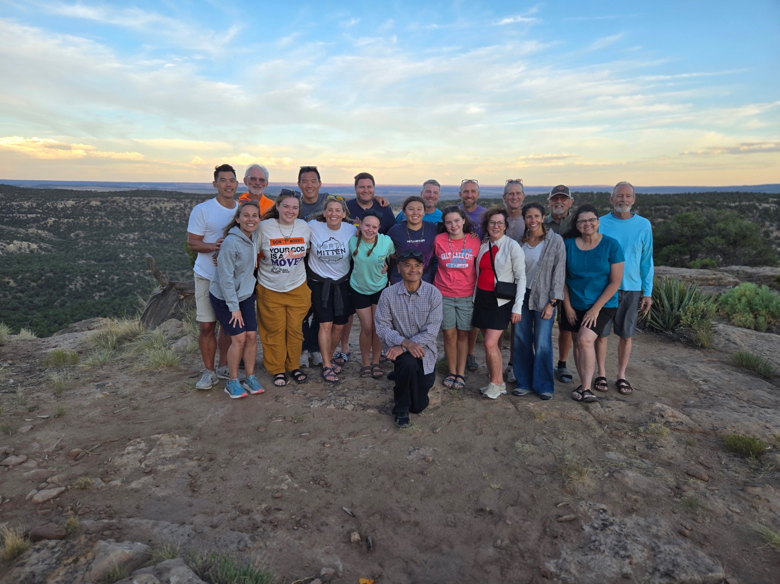

High School Mission Trip – Arizona House of Joy
June 14 – June 20, 2025

We are excited for our students to serve Kensington’s newest global partner, House of Joy Church (Tse ee gai), located atop Black Mesa in Arizona. Kensington partners with Experience Mission, which has worked alongside Pastor JR Wilson Jr. and his congregation since 2009, building a strong, trusted relationship. Pastor JR serves his community sacrificially, leading ministries that meet both spiritual and practical needs.
The Navajo Nation, roughly the size of West Virginia, has only 13 full-service grocery stores, making it a food desert. House of Joy operates a food pantry for families in need and hosts summer tent revivals—an important cultural tradition that brings the community together for worship and fellowship. Mission teams partner with House of Joy through home and church repairs, Kids Club ministry, and meaningful time with the local community.
Learn more at www.experiencemission.org

FAQ’s

How do we travel there?
We travel to Arizona on a direct flight from Detroit to Phoenix. We then hop in vans and travel 5 hours north to Black Mesa in Navajo Nation.

Where do students stay?
Students will be staying in House of Joy church. Students will sleep on air mattresses in the sanctuary. There will be separation between girls and boys.

What about showers?
Outdoor showers are available. Water is limited so these will be quick rinses. Students will find these showers to be surprisingly refreshing!

What about air conditioning?
There is no air conditioning. Students may bring a small portable fan in their bag if they can fit it in their bags. The temperatures are moderately warm at night – usually in the 70s.

What about meals?
Meals are prepared by the Experience Mission staff. These are basic American meals, bbq chicken, pasta, burgers, etc. The local community may prepare a meal for the team and this includes delicious fry bread!

What is the cost?
The total cost of the trip is $1,900. There is a $200 deposit when you register. We provide resources and train students on how to fundraise. We fully believe every student can pay for the trip in full through fundraising. If you have concerns about this, please reach out to us.

How much extra money should my student bring?
Many students like to buy pops and snacks at the local gas stations or gifts to bring home. Your student can bring $20-$30 for these snacks. THIS IS OPTIONAL

When do you leave/when is pick up?
We will meet…Sunday, June 14th at DTW Airport. Terminal and an exact time will be communicated closer to departure.
We will return…Saturday, June 20th at DTW Airport.

Can my student bring their cell phone?
For our annual high school mission trip, students may have their phones during travel days and for one 30-minute period each day to connect with family. Phones are helpful for airport navigation and keeping families updated during travel. Once we arrive at our mission partner site, phone use will be limited for the same reasons outlined in our full cell phone policy—to help students stay focused, safe, and fully engaged.

Medications?
Students who are taking medication during the time of the trip will give all medication to us along with a medication form. Please communicate with us their medication needs ahead of time so we can plan for this. We go into more detail in our trainings before leaving.

Security?
The students will always have background checked, adult supervision throughout the trip.

Ministry Activities
Students will participate in building projects like foundation pouring, siding, roofing, or running Kids club. The Experience Mission staff will train each student on how to do these different work projects upon arrival at House of Joy.
Phoenix Night
Before we head home, we will enjoy a nice meal together at a restaurant in Scottsdale and spend the night at a hotel in Phoenix. This time is intentionally set aside for students to debrief and reflect on their experience as a team. It provides space to process the week—what they saw, what they learned, and how God worked through them and others during our time away. Students will stay two to a room and will have the opportunity to take long, hot showers before boarding the plane and returning home.

Registration

Registration process:
- Register with Kensington Church at: Kensingtonchurch.org/go
- There is a $200 non-refundable deposit due at registration. The rest can be either paid or fundraised through a donation page we setup for you. Please communicate with the leader how you plan to cover the cost of the trip.

REGISTRATION DEALINE IS MARCH 31!

Forms

All Forms will be emailed to you to complete after you’re registered.
- DocuSign
- Experience Mission Registration

Fundraising

We encourage students/leaders to fundraise for this trip. There are many different ways to raise support, but one of the most effective ways is by sending out support letters to family and friends. We will go over this in detail during our first team meeting, as well as mention some other ways to fundraise. We encourage everyone to begin fundraising right away! Your fundraising page is setup up on registration, and you can view it when you log on to your profile on Kensington’s website. When you login, look for the section “short term trips” on your profile page. You should see our trip, and you can then edit your personal page to send out. This is the link you should point people toward for fundraising. See the letter below to help you draft yours and get started!

*The letter below is a generic letter and therefore needs to be edited by you for this specific trip and your personal info.*

SAMPLE SUPPORT LETTER

Dear Family and Friends,
I hope things are going well with you. I have some exciting news that I wanted to share!
A group from my church will be going on a short-term trip to Pittsburgh, PA. I have thought about this, prayed, and talked it over with many close friends. I really feel like this is an opportunity that I cannot pass up.

We are making the trip with our church’s middle school ministry, as the trip will be focused on serving the people of Pittsburgh in numerous service projects, building community, and personally growing in my faith.
The dates of the trip are June 21-26th. The total cost of the trip is $450.

I am writing to you to ask for your financial support and prayer as anything you are able
to give would be helpful!

If you are unable to give at this time, I completely understand! I truly covet your prayers
as I begin to plan for this trip and ask God for a servant’s heart when I’m helping the Pittsburgh community. As you can imagine, raising support is sometimes difficult,
but I know that if it is the Lord’s will that I make this trip, then He will provide.

While on the trip, I will have the opportunity to:
• Spend time ministering to the community with local outreach.
• Grow in my faith in small groups, teaching, musical worship, and serving.
• Learn what it means to live on mission and to have a servant’s heart.
• We will be partner with Boys and Girls Clubs, housing organizations, local food pantries, international humanitarian aid organizations, among other incredible serving opportunities.

There are two ways you can make a tax-deductible donation to our trip. Either complete
the enclosed slip and use the pre-addressed envelope, or donate on-line by going to the
following link: www.kensingtonchurch.org/trips (click the Student Serve Camp Middle School event tag)

A reply by May 31st, 2019 would be appreciated.

My desire is to allow God to use me to impact others for Him, and to allow Him to
change me at the same time. Please continue to pray for me as these plans fall into
place.

Love,

